Primary One Parental Information

Areas of Learning
Children are encouraged to gain thinking skills and personal capabilities throughout all Areas of Learning.
1. World Around Us
2. Language and Communication
3. Mathematics and Numeracy
4. Using ICT
5. The Arts
6. RE and PDMU
7. PE

The World Around Us
In Primary 1 we cover a range of topics, parents will be notified of new topics on Seesaw via the P1 newsletters.
During World Around Us activities, children will encouraged to be inquisitive and use their critical thinking skills. Learning experiences will take place indoors and outdoors.
Please ensure that your child comes to school wearing a coat, hat, scarf, etc in the colder months. We will also contact parents about bringing Welly boots into school, which will remain in school. These will all help facilitate our outdoor learning.
Play Based Learning
Activities are planned in correspondence with learning in Literacy, Numeracy and The World Around Us. Play Based Learning is central to the teaching and learning in Foundation Stage.
- A wide range of different playful activities are provided, which are ultimately child led. Teachers will make appropriate enhancements in accordance with the teaching and learning in class.
- Children will develop a range of skills, including: Communication, Social interaction, Problem, Solving, Decision Making and Creativity.

Literacy
Jolly Phonics
As a school we follow the Jolly Phonics programme. This is a multi-sensory approach, in which children will:
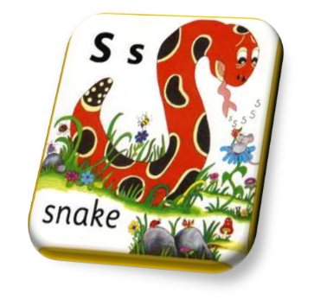
- Recognise Jolly Phonics character
- Identify the letter sound
- Carry out the action that correlates with the sound
- Learn a song that accompanies each sound
- Become aware of the formation of the letter
- Identify the letter name
Please note, the sounds taught in the Jolly Phonics programme do not follow alphabetical order. The Jolly Phonics sounds are taught in specific sets, which aim to help develop word attack skills.
- Set 1: s, a, t, i, p, n
- Set 2: c/k, h, e, r, m, d
- Set 3: g, o, u, l, f, b
- Set 4: j, z, w, v, y, x, qu
We focus on initial sounds then progress to final sounds. The children are also introduced to some blends (e.g., sh, ch) and rhyming patterns (bat, cat…). Parental guidance will be provided with each letter.

Reading
The children will initially focus on shared reading experiences to familiarize print through the text. The following activities are gradually introduced in Term 1.
- High frequency words are introduced (vocabulary featured in the P1 reading scheme used e.g. ‘mum’, ‘look’ etc)
- Word bags will be sent home, to aid consolidation.
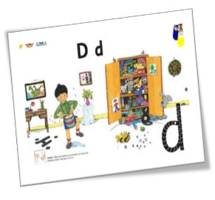
- Interest / picture books will be introduced, to share for enjoyment.
In Term 2 Guided Reading is then introduced.
Writing
Similar to Jolly Phonics, Writing activities will take a multi-sensory approach.
Time is spent initially working on pre-writing skills-pencil grip, fine motor skills, mark making (e.g., tracing in the sand, the air, then practicing on the whiteboards). The children learn the accurate formation of each letter, and progress from multi-sensory mark making experiences to formal letter formation. Initially the children will trace over adult writing, then move to copy under adult writing and eventually start to write independently.
Letter Families
Downward  l, t, i, r, n, m, h, k, j, p, b  Smiling  u, y | 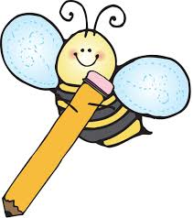  Apple and caterpillar  c, o, a, d, g, q, s, e, f  Zig-Zag  v, w, x, z
Numeracy
Number
Throughout the year, pupils will be given the opportunity to develop their understanding of all numbers 0-10 and then 11-20. Pupils should be able to:-
- Recognise and name each number up to 10, extending to 20 by the end of the year.
- Count a set of objects up to 10, with one to one correspondence.
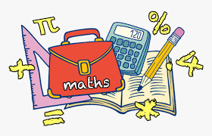
- Count forwards and backwards within 10/20.
- Count accurately from different starting and finishing numbers e.g. from 3 to 9 or from 10 to 4.
- Name the number after, before and between.
- 1 more than/ 1 less than (basic addition and subtraction)
- Identify some ways of making each number e.g. 6 is the same as 5 and 1, 2 and 4 or 6 and 0.
- Accurately write each numeral.
- Money using 1p coins initially.

Shape and Space
Through the course of the year, children will be given opportunities to:
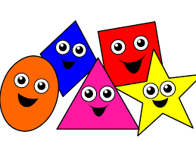
- Sort, recognise and name basic 2D and 3D shapes within their environment and throughout their play.
- Begin to identify some basic properties e.g. a rectangle has 4 sides or a triangle has 3 corners.
Handling Data
Through the course of the year, children will be given opportunities to:
- Recognise similarities and differences within a group of objects.
- Progress from sorting random objects to sorting for 1/2 criteria chosen by the adult/child e.g. type, colour, size, shape etc.
- Collecting, recording and interpreting simple graphs.
Measures
Through the course of the year, children will be given opportunities to:
- Use non standard units to carry out investigations e.g. cubes, hand/foot span, teddies etc, relating to size, length, height and weight.
- Time- Sequence familiar events; days of the week, be aware of seasons, recognise ‘special’ times and identify o’clock times.

Using ICT
ICT is used across all Areas of Learning. Games and websites are used to reinforce learning. Both classes have regular access to an Interactive Whiteboard, iPads and computers in our shared area.
Children encouraged to develop skills in ICT: Mouse control, Basic knowledge of the keyboard, E-Safety and Programming a digital robot (Beebot).
Targets
As part of a whole school initiative, the children will talk about their learning and, with the guidance of their teacher, will set individual targets to aim for during the year. These are displayed on the children’s desks. An evaluation of each target is placed into a Target Book. These are completed termly. Target books are sent home to inform parents.
Homework
Homework will begin at the end of September.
P1 homework will include the following:
- Literacy homework/Jolly Phonics
- Numeracy homework
- Word Bag
- Picture/discussion book
- Reading book (from Term 2 on)
Teachers will be in contact via Seesaw with more information regarding Homework.

Shared Education Signature Project (SESP)
What is SESP?
Schools from different sectors in education, providing opportunities for pupils, staff and the community to engage in collaborative and meaningful learning experiences together.
At Oakfield our pupils are currently participating in this project with Acorn Integrated Primary School.

Safer Schools NI App

Our School is pleased to use the Safer Schools NI App. This App provides relevant and critical updates from the Department of Education and from Safer Schools which will keep parents and carers up to date with emerging trends, risks and threats in the digital world.
The Safer Schools NI App is mentioned and referenced in our Fortnightly Newsletters.
For more information, download the Safer Schools NI App via the App or play store.
- Select your role – ‘Parent/Carer’
- Login or register with your email and password of choice
- Select ‘Oakfield Primary School’
- Use the passcode ‘6025’

Top Tips
- Each morning, children should remove their homework folder and snack from their school bag. They should bring these to their classroom.
- Please encourage your child not to bring toys or teddy bears into school on a daily basis as these can be a distraction.
- From Monday 28th September the school day will end at 2pm. Please inform the class teacher or Mrs Craig in the office if a different adult is collecting them.
- If you have any queries or concerns, please contact us via Seesaw or arrange an appointment with the school office.

Thank you!

Mrs Stuart & Miss McIlwaine

